Types of Database

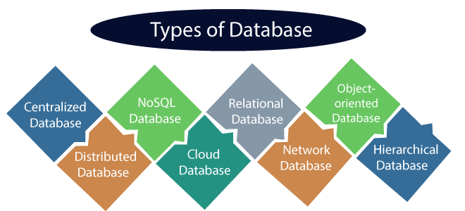

**Centralized Database:** It is the type of database that stores data at a centralized database system. It comforts the users to access the stored data from different locations through several applications. These applications contain the authentication process to let user’s access data securely.

**Example**: Central Library that carries a central database of each library in a college/university.

**Distributed Database:** Unlike a centralized database system, in distributed systems, data is distributed among different database systems of an organization. These database systems are connected via communication links. Such links help the end-users to access the data easily. **Examples** of the Distributed database are Apache Cassandra, HBase, Ignite, etc.

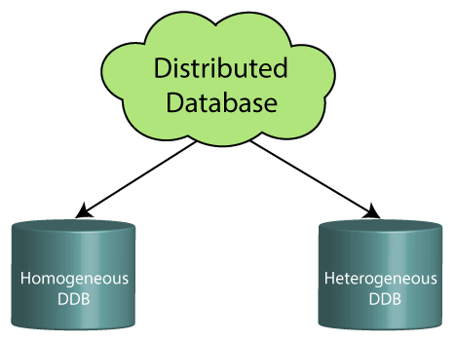

* **Homogeneous DDB:** Those database systems which execute on the same operating system and use the same application process and carry the same hardware devices.
* **Heterogeneous DDB:** Those database systems which execute on different operating systems under different application procedures, and carries different hardware devices.

**Advantage :**

* the system can be expanded by including new computers and connecting them to the distributed system.
* One server failure will not affect the entire data set.

**Relational Database:** This database is based on the relational data model, which stores data in the form of rows(tuple) and columns(attributes), and together forms a table(relation). A relational database uses SQL for storing, manipulating, as well as maintaining the data. E.F. Codd invented the database in 1970. Each table in the database carries a key that makes the data unique from others. **Examples** of Relational databases are MySQL, Microsoft SQL Server, Oracle, etc.

**There are following four commonly known properties of a relational model known as ACID properties**

**A means Atomicity:** This ensures the data operation will complete either with success or with failure. It follows the 'all or nothing' strategy. For example, a transaction will either be committed or will abort.

**C means Consistency:** If we perform any operation over the data, its value before and after the operation should be preserved. For example, the account balance before and after the transaction should be correct, i.e., it should remain conserved.

**I means Isolation:** There can be concurrent users for accessing data at the same time from the database. Thus, isolation between the data should remain isolated. For example, when multiple transactions occur at the same time, one transaction effects should not be visible to the other transactions in the database.

**D means Durability:** It ensures that once it completes the operation and commits the data, data changes should remain permanent.